# Algorithm for file updates in Python

## Project description

This small project is about working with called allow_list.txt .it has IP address

inside.The idea is to open the file ,read the data ,turn it into a list ,remove some IPs we

Don’t want ,and then save the cleaned list back to the same list.

## Open the file that contains the allow list

First i made a variable for the file name :

I also made a list called remove_list that has the IP addresses i don’t want in the allow list.

Finally , I printed both variables .

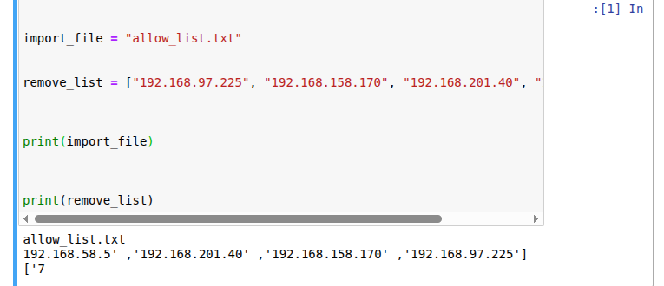

## Read the file contents

I used with open(import _file, “r”) as file: to open the file and file.read()

To load everything into a variable called allow_text

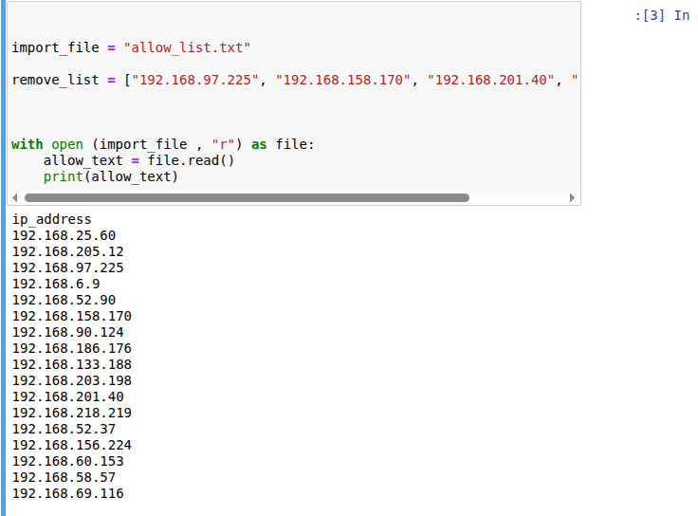

## Convert the string into a list

A first ,everything from the file came in as one big string .I used .splitlines() to

Python list.

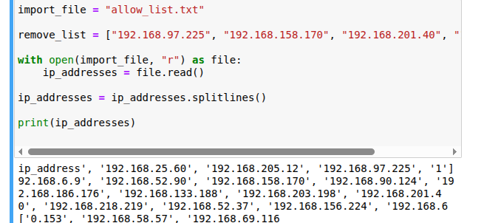

## Iterate through the remove list

Now that I split the string into a list ,I made a for loop to go through each IP one by one.

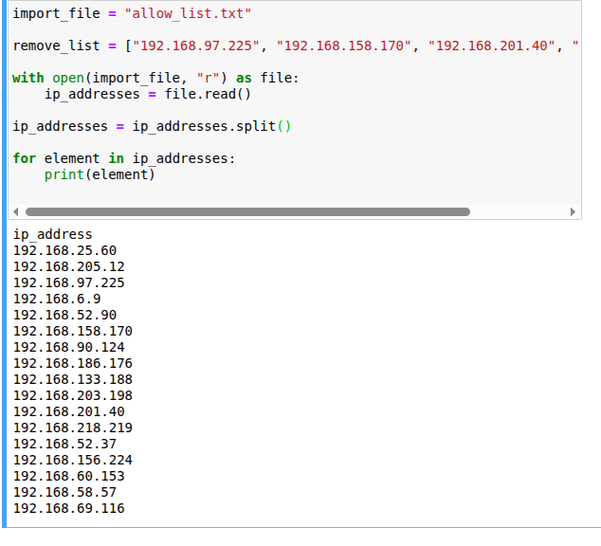

## Remove IP addresses that are on the remove list

I made a simple for loop that goes through each IP .Inside the loop I just checked if the current IP was in the removed list ,and if it was ,I took it out of the main list ,then I printed that.

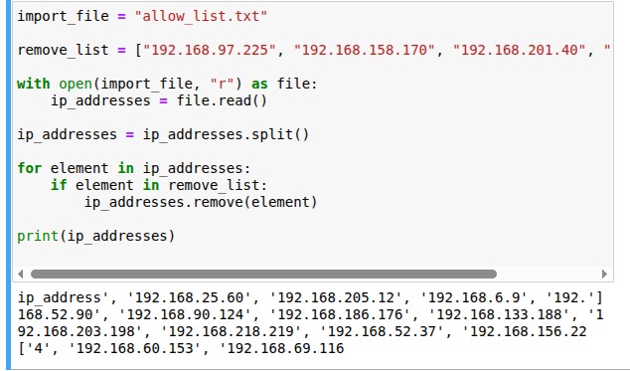

## 

## Summary

I put all the steps into one function called update_file,which takes the file name and

the list of IPs to remove. then I called it with “allow_list_txt” and the four IPs.After

that,I opened the file again ,read the new contents into “text” ,and printed it.

